SQL Assessment 1
Write queries for the following

- Create the Customer table with the following columns.
CustomerId Number(5)
Cust_Name varchar2(20)
Address1 Varchar2(30)
Address2 Varchar2(30)

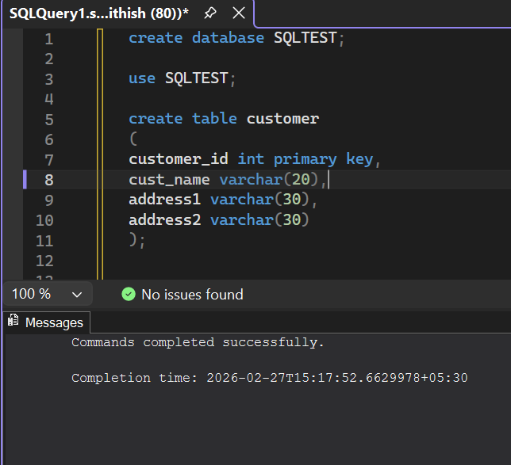

- Modify the Customer table Cust_Name column of datatype with Varchar2(30), rename the column to CustomerName and it should not accept Nulls.

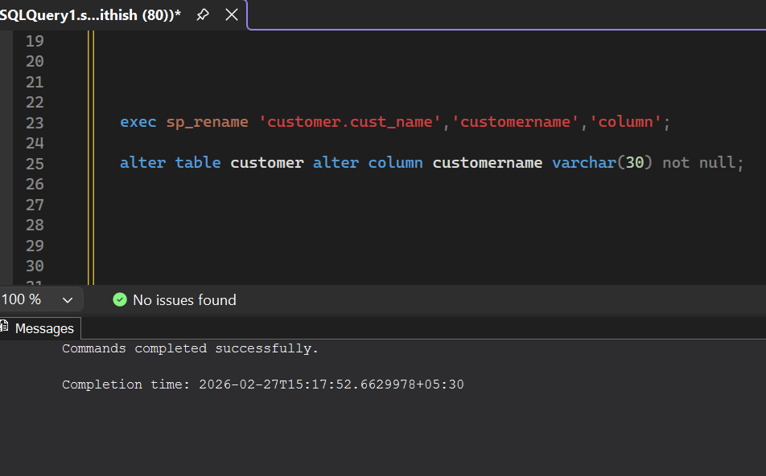

3. Add the following Columns to the Customer table.
Gender Varchar2(1)
Age Number(3)
PhoneNo Number(10)
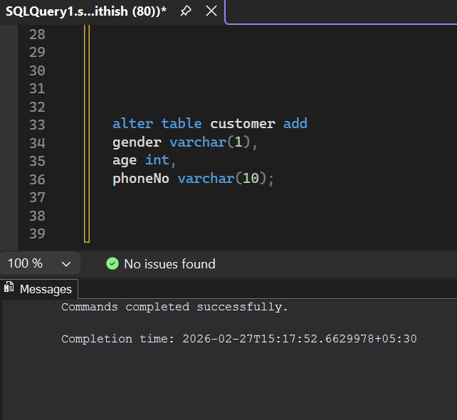

4. Add the below records to the Customer table:
(1000, ‘Allen’, ‘#115 Chicago’, ‘#115 Chicago’, ‘M’, ‘25, 7878776’)
1000, Allen, #115 Chicago, #115 Chicago, M, 25, 7878776
1001, George, #116 France, #116 France, M, 25, 434524
1002, Becker, #114 New York, #114 New York, M, 45, 431525)

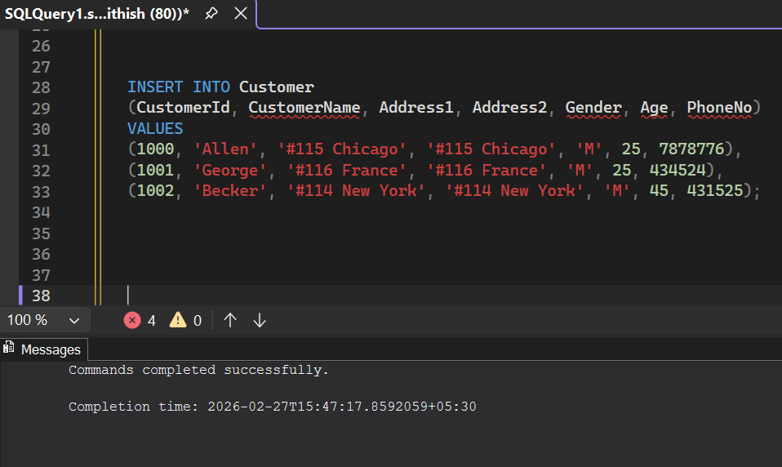
- Add the Primary key constraint for Customerld with the name Custld_Prim.
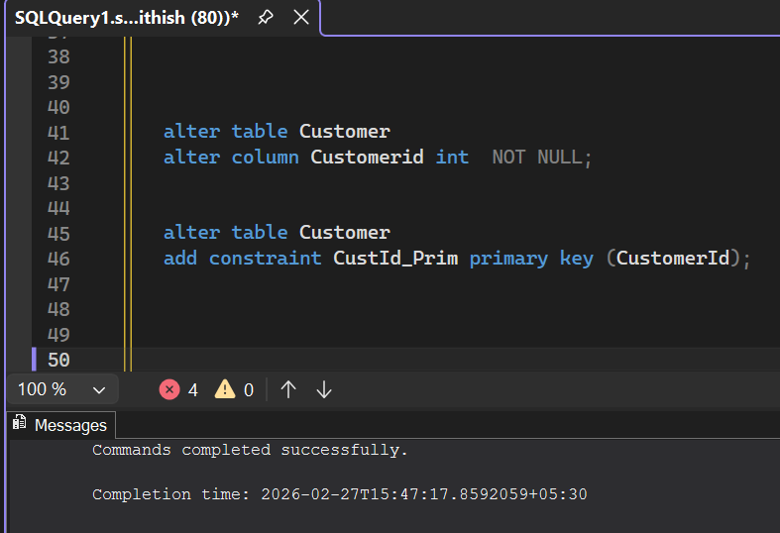

6. a) Disable the constraint on CustomerId, and insert the following data:
1002, Becker, #114 New York, #114 New york , M, 45, 431525
1003, Nanapatekar, #115 India, #115 India , M, 45, 431525
b) Drop the constraint Custld_Prim on CustomerId and insert the following Data.
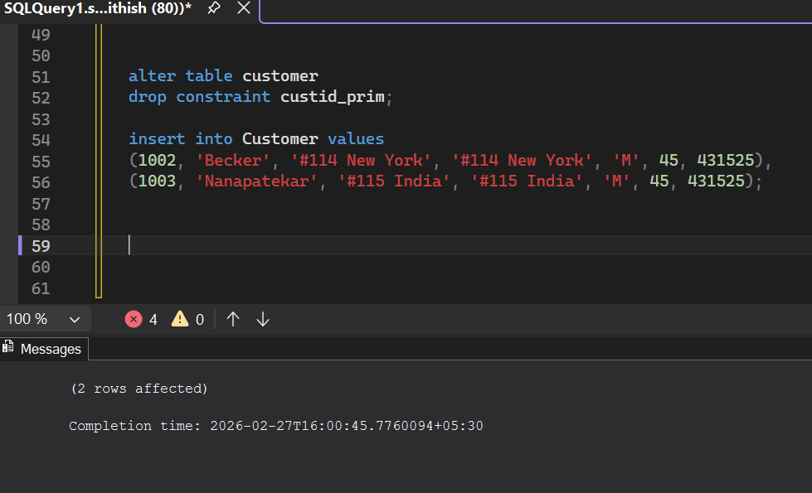
7. Alter Customer table, drop constraint Custid_Prim.
1002, Becker, #114 New York, #114 New york , M, 45, 431525, 15000.50
1003, Nanapatekar, #115 India, #115 India , M, 45, 431525, 20000.50

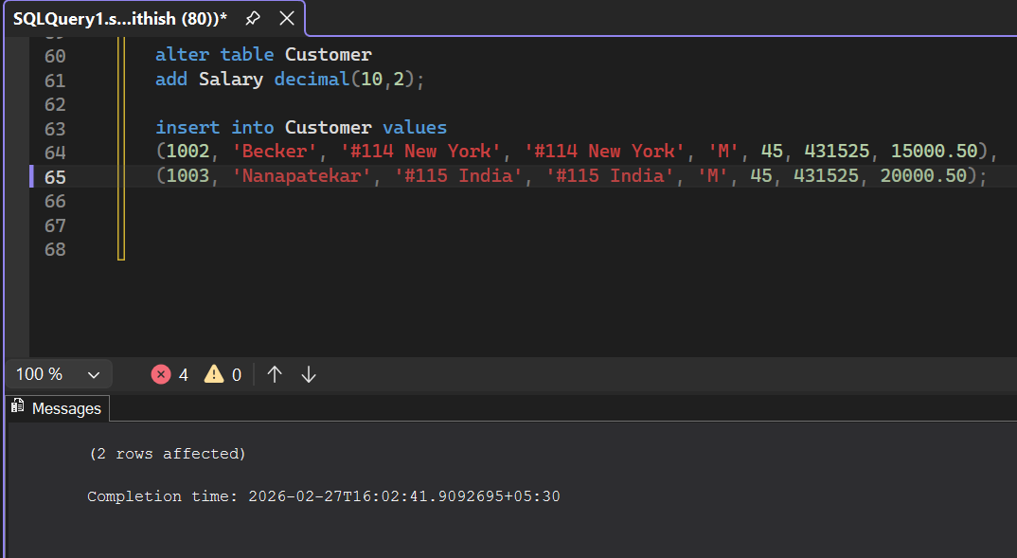
8. Create Employee table with same structure as EMP table
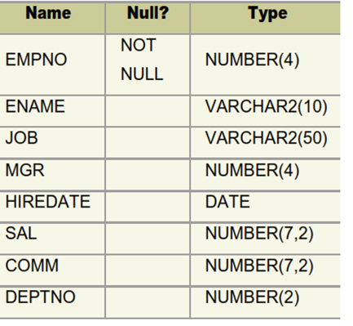
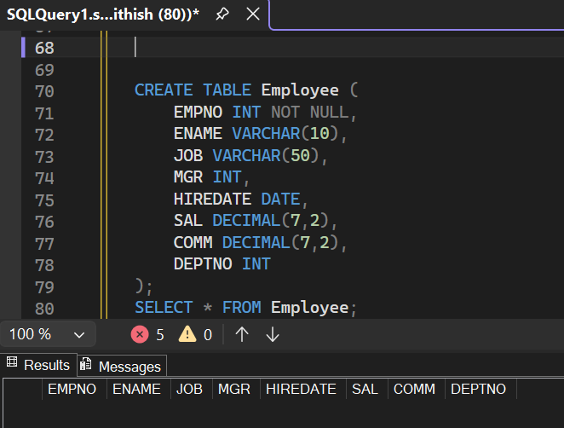
9. Insert the following data in the above table
insert into Employee (EMPNO,ENAME,SAL,DEPTNo)
values(7369,'SMITH',800,20),(7499,'ALLEN',1600,30),
(7521,'WARD',1250,30),(7566,'JONES',2975,20),
(7654,'MARTIN',1250,30),(7698,'BLAKE',2850,30),
(7782,'CLARK',2450,10),(7788,'SCOTT',3000,20),
(7839,'KING',5000,10),(7844,'TURNER',1500,30),
(7876,'ADAMS',1100,20),(7900,'JAMES',950,30),
(7902,'FORD',3000,20),(7934,',MILLER',1300,10);
select*from Employee;

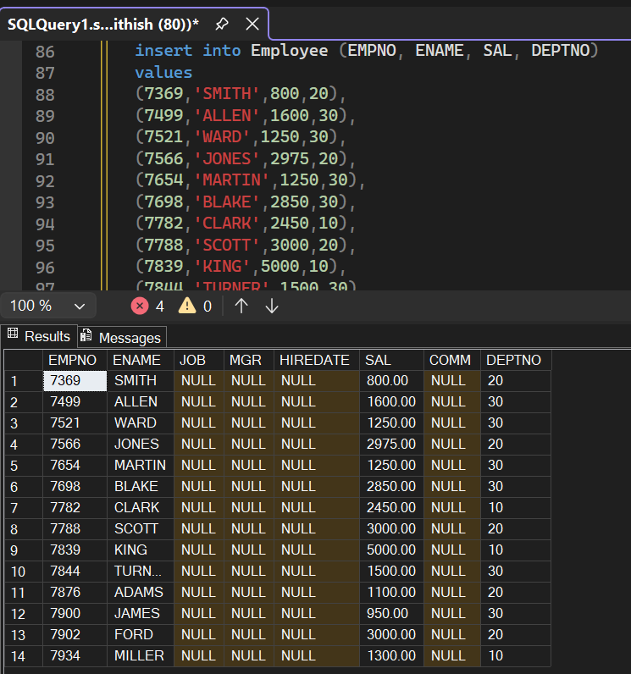
10. Write a query to populate Employee table using EMP table’s empno, ename, sal,, deptno columns.
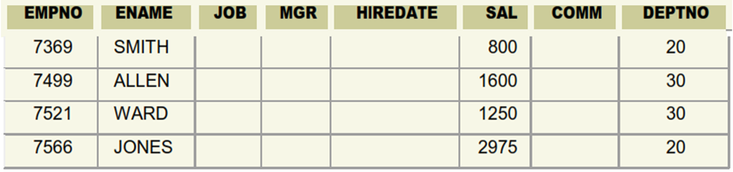
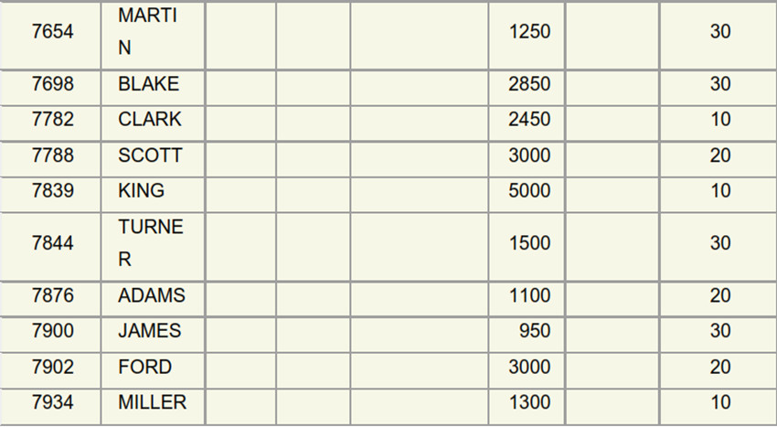

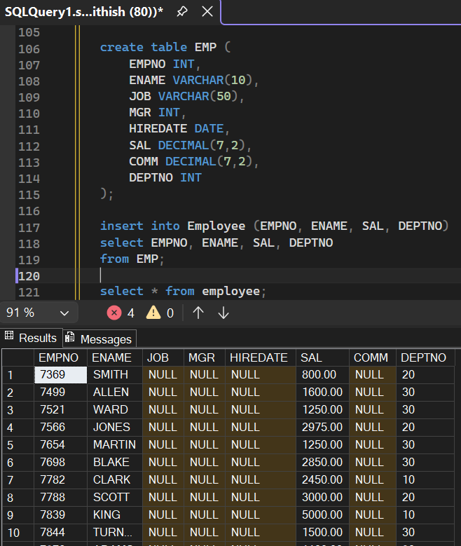
11.
- Write a query to change the job and deptno of employee whose empno is 7698 to the job and deptno of employee having empno 7788.

b. Write a query to change the deptno of employee with empno 7788 to that of employee having empno 7698
12. Delete the details of department whose department name is ‘SALES’.
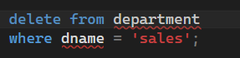
13. Insert the following rows to the Employee table
1000,Allen, Clerk,1001,12-jan-01, 3000, 2,10
1001,George, analyst, null, 08 Sep 92, 5000,0, 10
1002, Becker, Manager, 1000, 4 Nov 92, 2800,4, 20
1003, 'Bill', Clerk, 1002, 4 Nov 92,3000, 0, 20
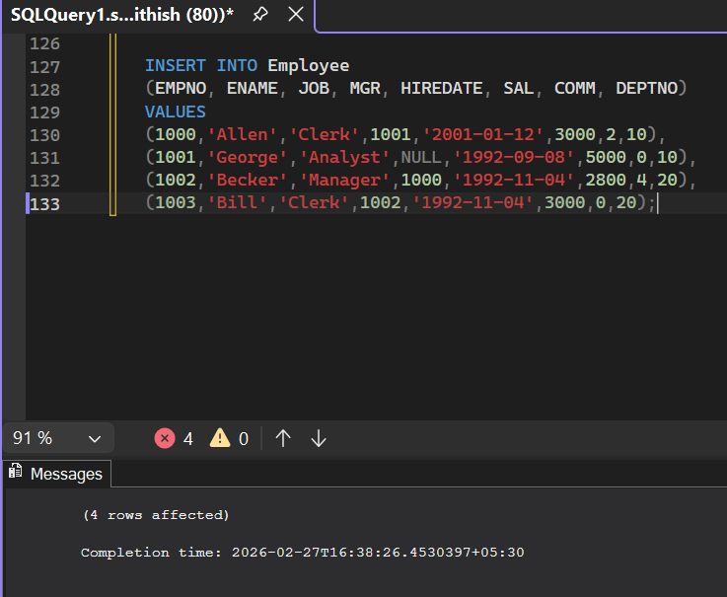

14.Create a Project Table with below structure
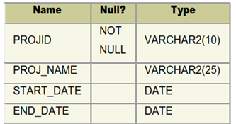
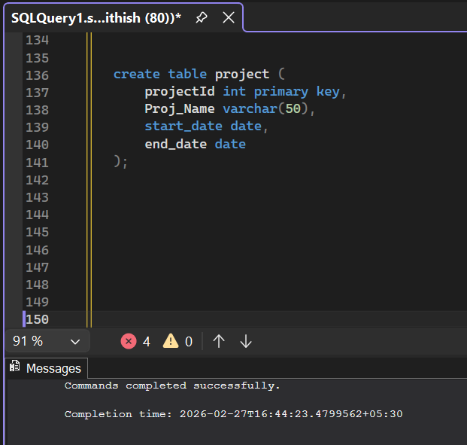
15. Insert Records into Project Table as deemed necessary and relevant

